**Title**

Validation issues in the discount and course_type fields

**Steps**

1.Login with admin credentials

2.Click on account

3.Click on Change Discount button

4.Choose Course Type from ddl

5.fill discount button with letters

6.fill course_count button with letters

7.Click on Change Discount button

**Expected result**: Discount and course_count buttons should accept only numeric data,the notification should be displayed about wrong input

**Actual Result:** The system allow to write in the fields not only numeric ,and after clicking Change Discount button discount is changed

Severity:Medium

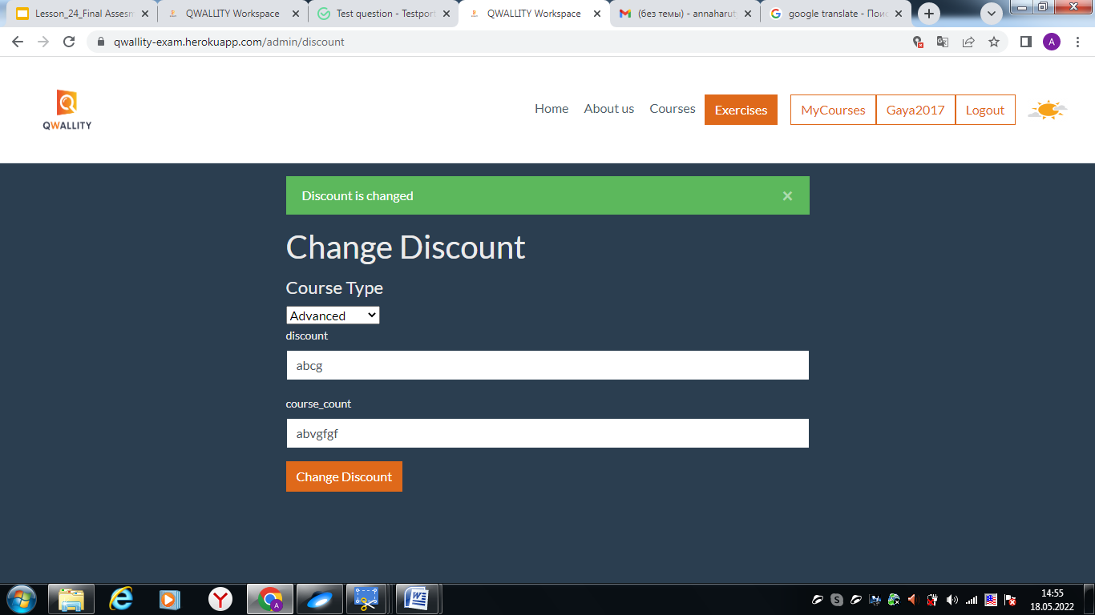

**Title**

Possibility to change discount with empty fields

**Steps**

1.Login with admin credentials

2.Click on account

3.Click on Change Discount button

4.Leave all fields empty

5.Click on Change Discount button

**Expected result:** The validation message should be displayed on the screen 'The information is missing' and don’t let to change discount.

**Actual Result: T**he system allow without filling fields to change discount

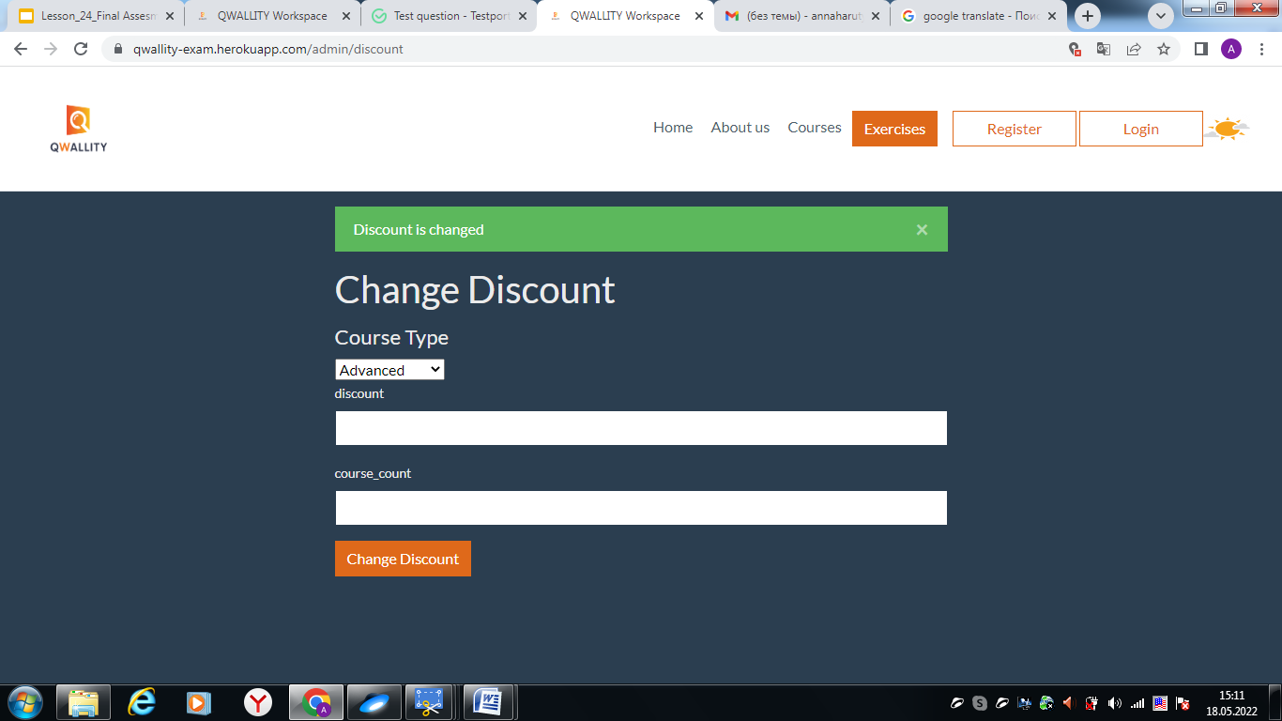

**Title**

**The input in the course_count field doesn’t take into account**

**Steps**

1.Login with admin credentials

2.Click on account

3.Click on Change Discount button

4.Choose Course Type from ddl ex.Advanced

5.fill discount button ex.10

6.fill course_count button ex.5

7.Click on Change Discount button

**Expected result:** 5 courses should be discounted

**Actual result:** All advanced courses are discounted

**Severity**:Critical

**Title**

Content and style of notification message is wrong

**Steps**

1.Login with admin credentials

2.Click on account

3.Click on Change Discount button

4.Choose Course Type from ddl ex.Advanced

5.fill discount button ex.10

6.fill course_count button ex.5

7.Click on Change Discount button

8,the notification message displayed on the screen

**Expected result:** the notification message should be in this form ’*Discount changes’.*

***Actual result: notification displayes without ‘ characters and instead the word changes it is written changed .Discount is changed***

***Severity:low***

